sourcedata:https://data.gov.in/catalog/district-rainfall-normal-mm-monthly-seasonal-and-annual-data-period-1951-2000

**Indian Rainfall data analysis:**

**Display first 5 rows of dataset:**

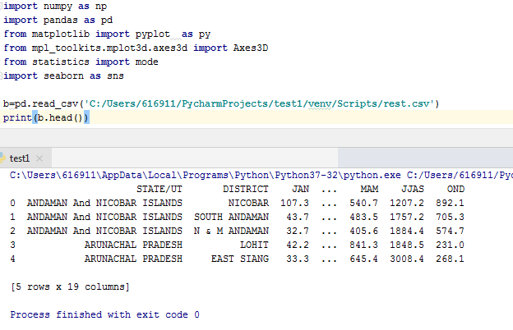

***Fetching the column wise statistical volume of data by means of mean,std,min,max,25%,75%***

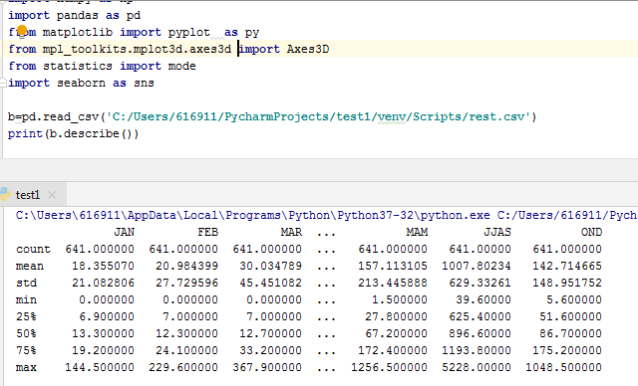

**Combining both state and district:**

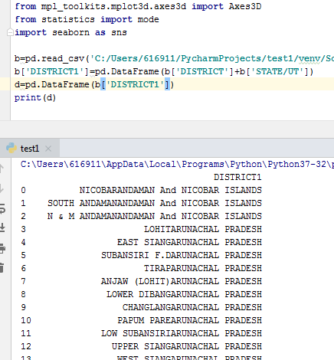

**Plotting scatter rainfall of “state+district” vs annual rainfall:**

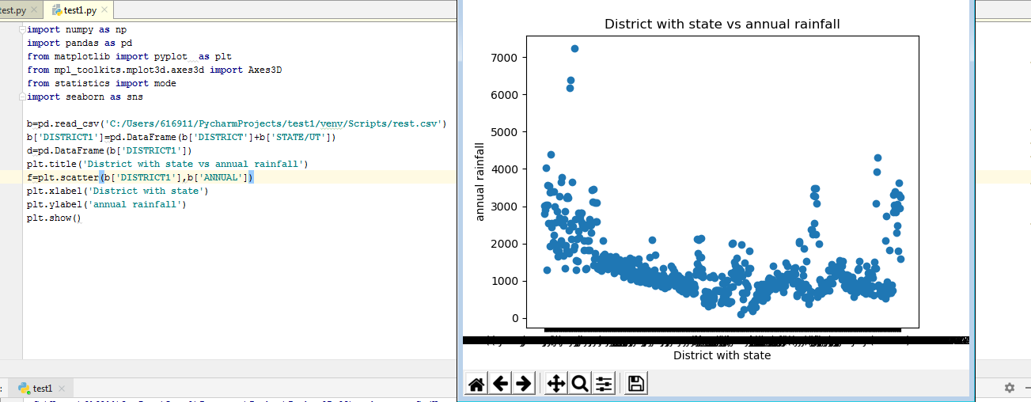

**Annual rainfall of state in seaborn:**

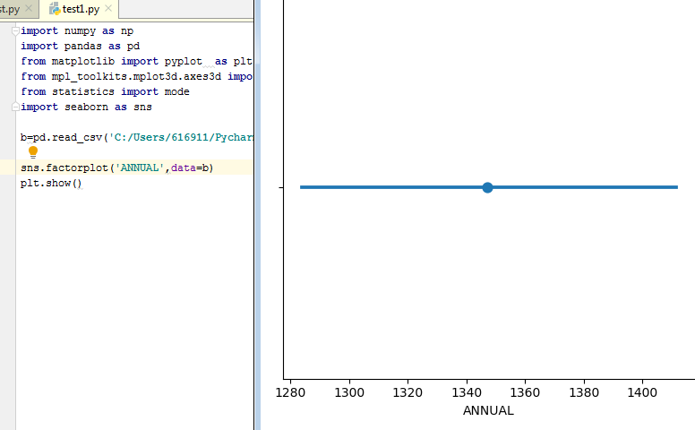

**Representing the amount of rainfall in jan month for all districts:**

